# Farm Management Information System (FMIS) Procedure

Flow Chart

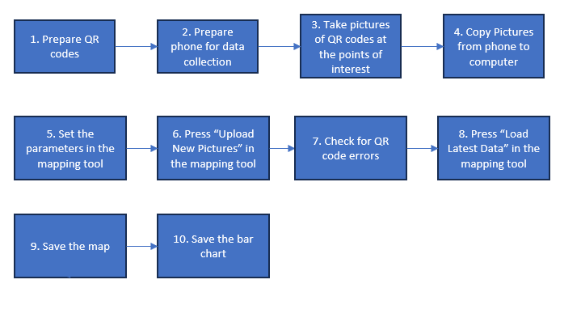

1. Prepare QR CODES
2. Prepare QR Codes using the QR Codes.xlsx file
   1. Enter the task type into a cell on the excel sheet
   2. Select the task you would like to generate a QR code for
   3. In the home menu, select the QR Code Tracker tool

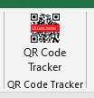

* 1. Click “Generate QR Code”
  2. Select the desired size of QR code. 250x250 is recommended for 4 QR codes per 8.5x11 sheets of paper
  3. Click “Generate QR Code”
  4. Repeat steps 1.1-1.6 until you have all the task types needed for the project.
  5. Arrange the QR codes to the desired configuration for printing. Page Break Preview is useful for this and can be found in the bottom right side of the excel window.



* 1. Print the file
  2. Take some test pictures with your phone. Ensure that a clear image of each QR code can be taken with only one QR code in frame at a time.
  3. Repeat steps 1.8-1.10 until step 1.10 is successful

1. Prepare phone for data collection
2. Prepare phone for data collection
   1. Ensure location services (GPS) is turned on
   2. Ensure at least 10 Gb of storage is available
   3. Turn off live pictures on iPhone
   4. Take a test picture and upload it to a computer (See Step 4)
   5. Inspect the properties of the picture and ensure the GPS data is in the metadata
   6. 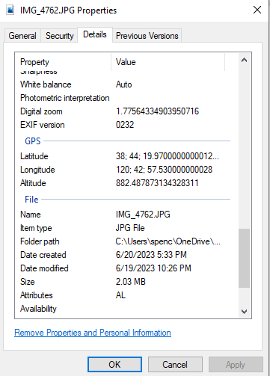
   7. An external battery for the phone is recommended. The data collection process quickly drains phone batteries.
3. take pictures of qr codes at points of interest
4. Take pictures of QR codes at points of interest
   1. Walk the farm row by row and take pictures when a location matches the description of the QR code. Walk between tree rows and record data for the immediate trees to the left and right.
   2. Only include one QR code in frame at a time while taking the picture
   3. Any shadows should not partially obscure the QR code. The QR code must be completely in shadow or in full sun. A QR code with partial shadow coverage will be unreadable by the mapping software and will need to be manually fixed later.
5. Copy pictures from phone to computer
6. Copy pictures from phone to computer
   1. Plug phone into the computer using a USB cable
   2. The computer or phone may ask for permission to view the pictures on the phone.
   3. Find the folder that contains the pictures that need to be uploaded.
   4. Copy the picture into the computer and name the folder appropriately
   5. Inspect the properties of a copied picture to check if it contains the GPS data
7. Set the parameters of the mapping tool
8. Set the parameters of the mapping tool
   1. The mapping tool will have default values listed for the parameters. These parameters tell the program where to find and store the necessary data. If you need to change these default values, enter the file or folder path and press submit.

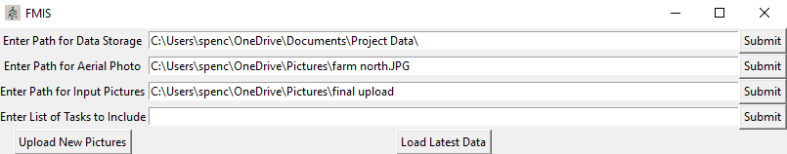

* 1. The last parameter allows you to select a subset of take to include on the map. The subset must be entered with the task name exactly as it appears on the QR code excel file with a comma and space between each task. The default for the last parameter will show all the tasks included in the dataset.

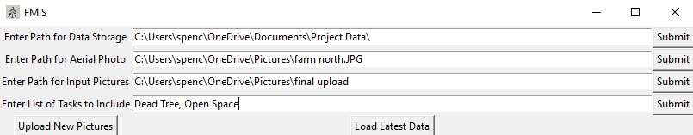

1. Press “upload new pictures”
2. Press “Upload New Picture”
   1. This button will read the QR codes and GPS coordinates from the specified files
   2. The data is stored in the specified data storage folder in a .cvs file named “picturedata” followed by a time stamp.
   3. The user interface will be unresponsive during this process. Do not try to interact with the window during this process. This step could take up to a half hour.
3. Check for QR CODE ERRORS
4. Check for QR code errors.
   1. In the data storage folder there will be a .cvs file with the name “errors” and a timestamp. Open this file
   2. This file will contain all the data points with QR code or gps errors. The gps errors cannot be repaired. This is why step 2.5 is important. The QR code errors can be repaired. delete any files with gps errors
   3. For each row find the file specified by the Picture File Path column using file explorer.
   4. Open the file and determine the task type that the picture was meant to record.
   5. Close the picture
   6. In the picture file name add the task type into the file name inside parentheses. For example IMG10.JPG meant to contain a Dead Tree task will become (Dead Tree)IMG10.JPG
   7. Repeat for every row in the errors file
   8. Repeat steps 6 and 7 until the errors file is empty
5. Press “Load Latest Data” in the mapping tool
6. Press “Load Latest Data” in the mapping tool
   1. Wait for the program to run. It will be unresponsive while it runs. The map should appear in about a minute.
7. Save the map
8. Save the map
   1. The map automatically saves in the Data Storage folder. This file can be moved or copied into another location when you want to use it.
   2. Alternatively, the picture can be saved directly from the pop up by clicking the save icon on the bottom banner of the pop up.

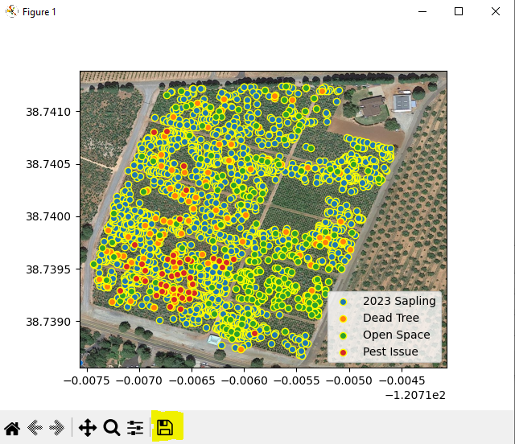

1. save the bar chart
2. Save the bar chart
   1. After the map is saved you can close the window.
   2. This will cause the bar chart to open in your default web browser.
   3. There is a camera icon in the top right banner that allows the image to de downloaded as a .png file.

